1. Click this link to be directed to the Maze game website:

<https://blockly.games/maze?lang=en>

1. To solve this maze, follow the instructions on the screen to help the player reach his destination.

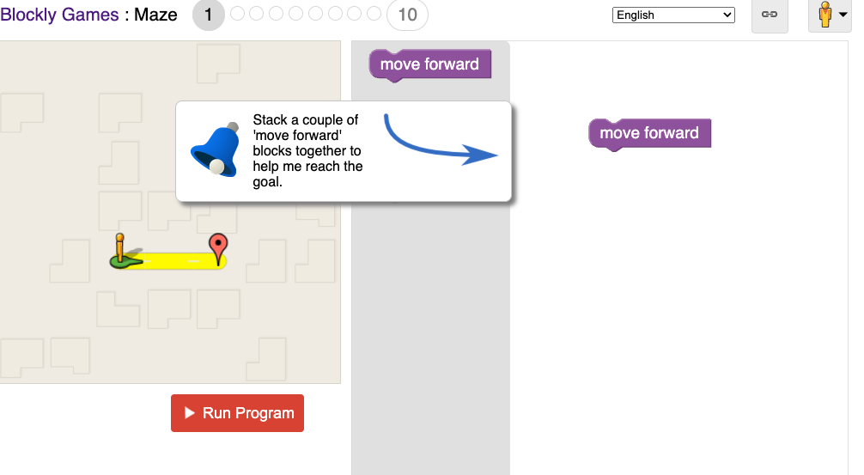

1. This is the completed maze for level one. Follow instructions on the screen & Click on [ Run Program]

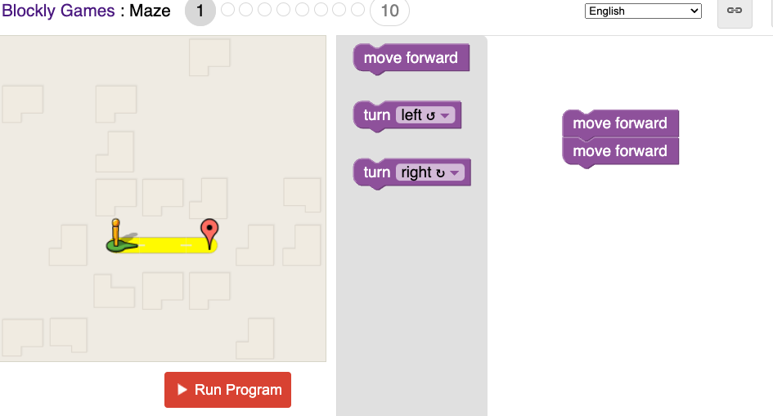

1. After you click Run Program this pop up appears. This shows the completion of level 1 and the lines of code in computer science that you used to complete the maze.

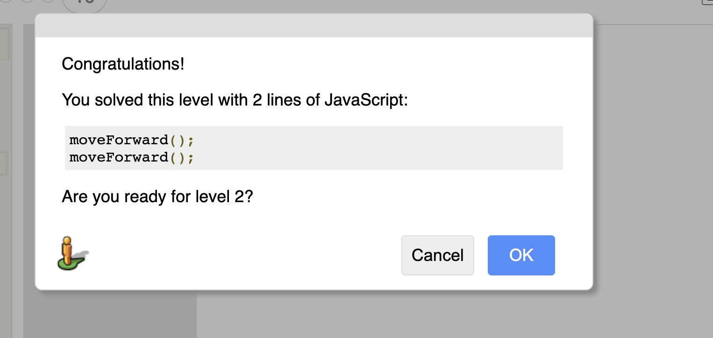

1. Follow the instructions for the rest of the levels to complete the maze.
2. Level 3 introduces you to loops. In this case your player is repeating the move forward action until it reaches the destination.

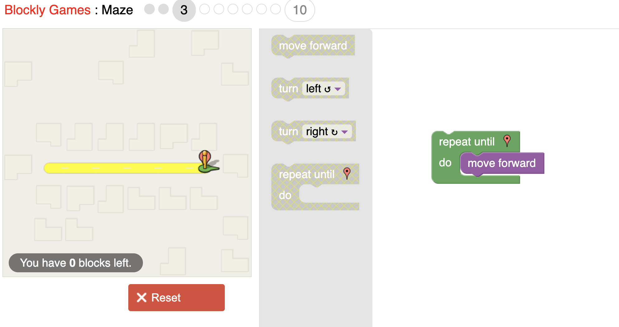

1. In terms of computer science code, this is the action being performed in level 3. This pops up after you successfully complete the maze in level 3.

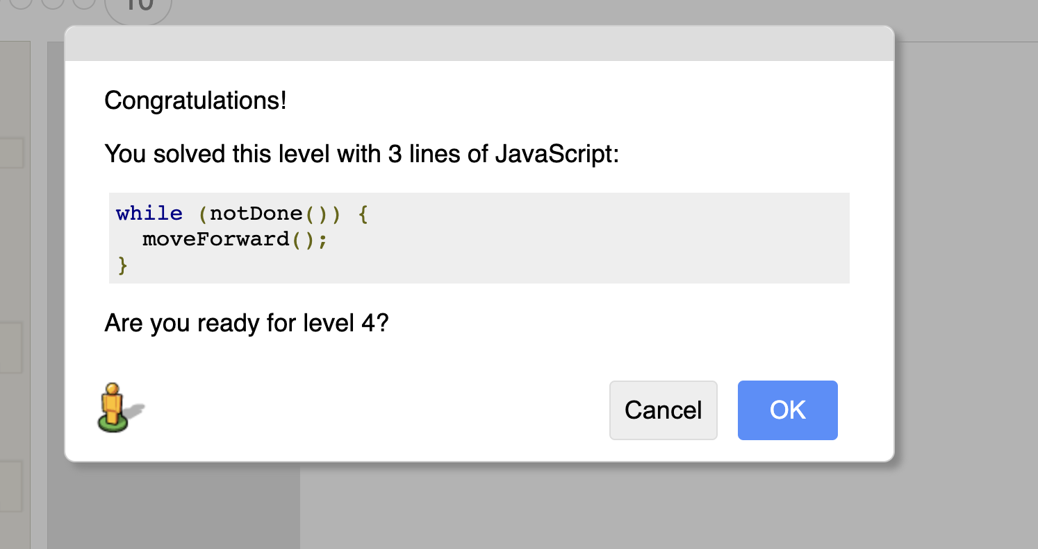

1. Use the idea in **(7)** to complete the next levels.
2. Level 6 introduces you to If blocks (if statements). The If block will only do something if the condition is true.

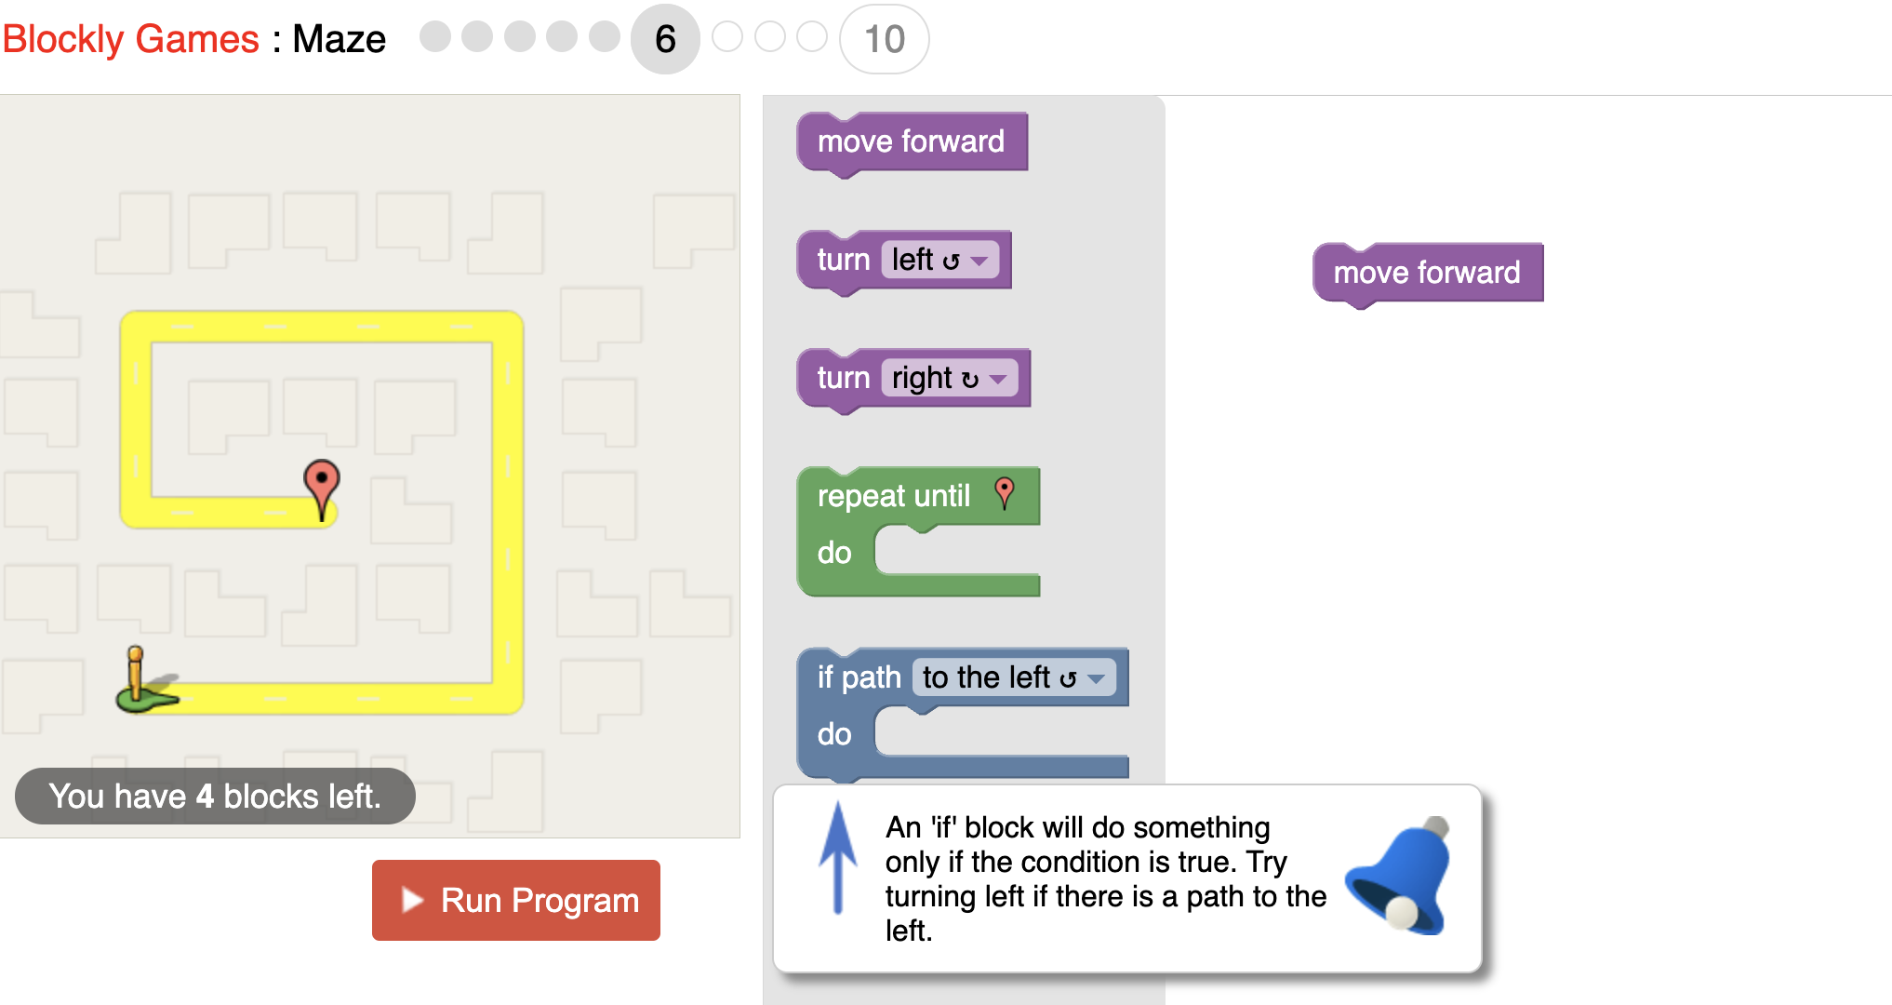

1. This is the completed maze for level 6.

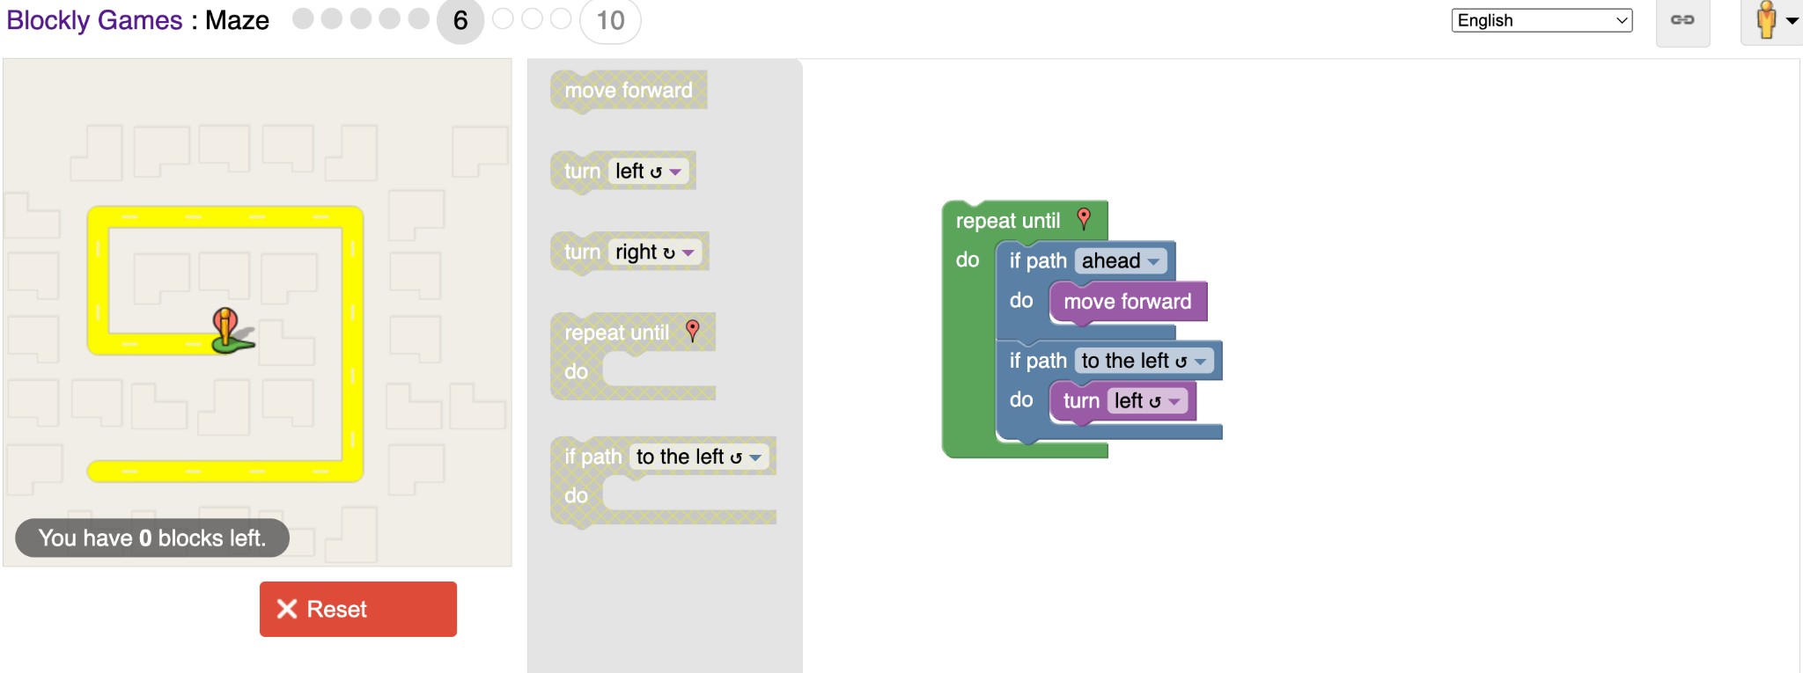

1. In terms of computer science code this is the action being performed at level 6.

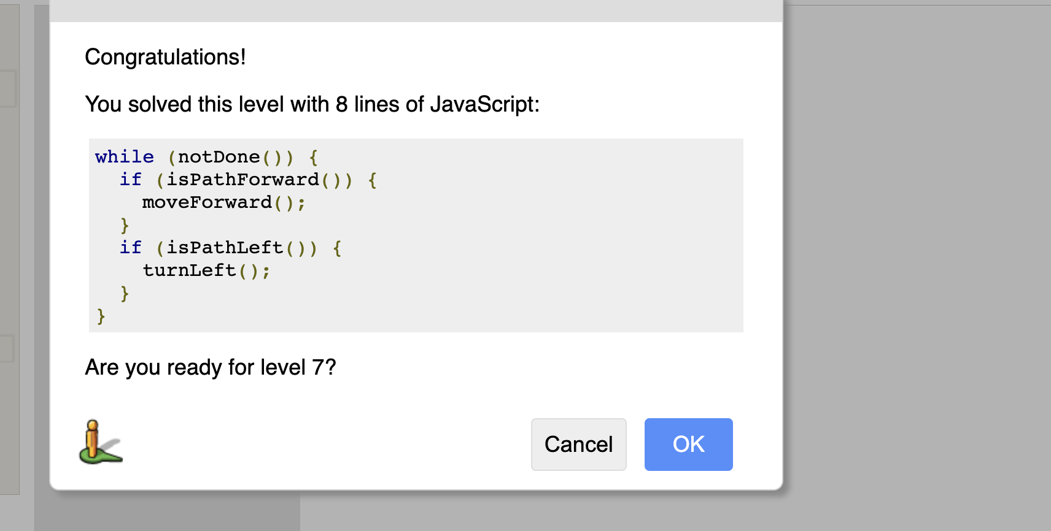

1. Use the idea above to complete the next levels.
2. Level 9 introduces you to the If - else block (if-else statement). If the statement is true do one thing, else do the other.

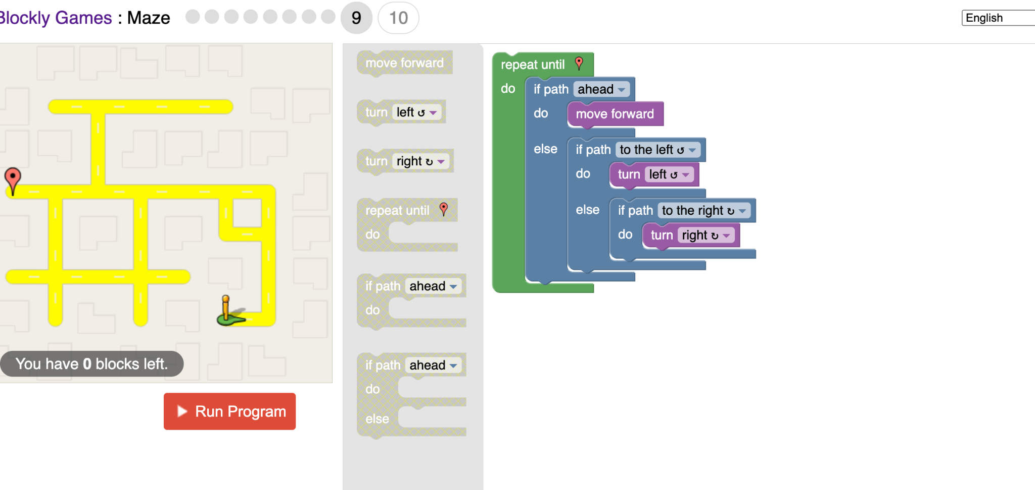

1. In terms of computer science code this is the action being performed at level 9.

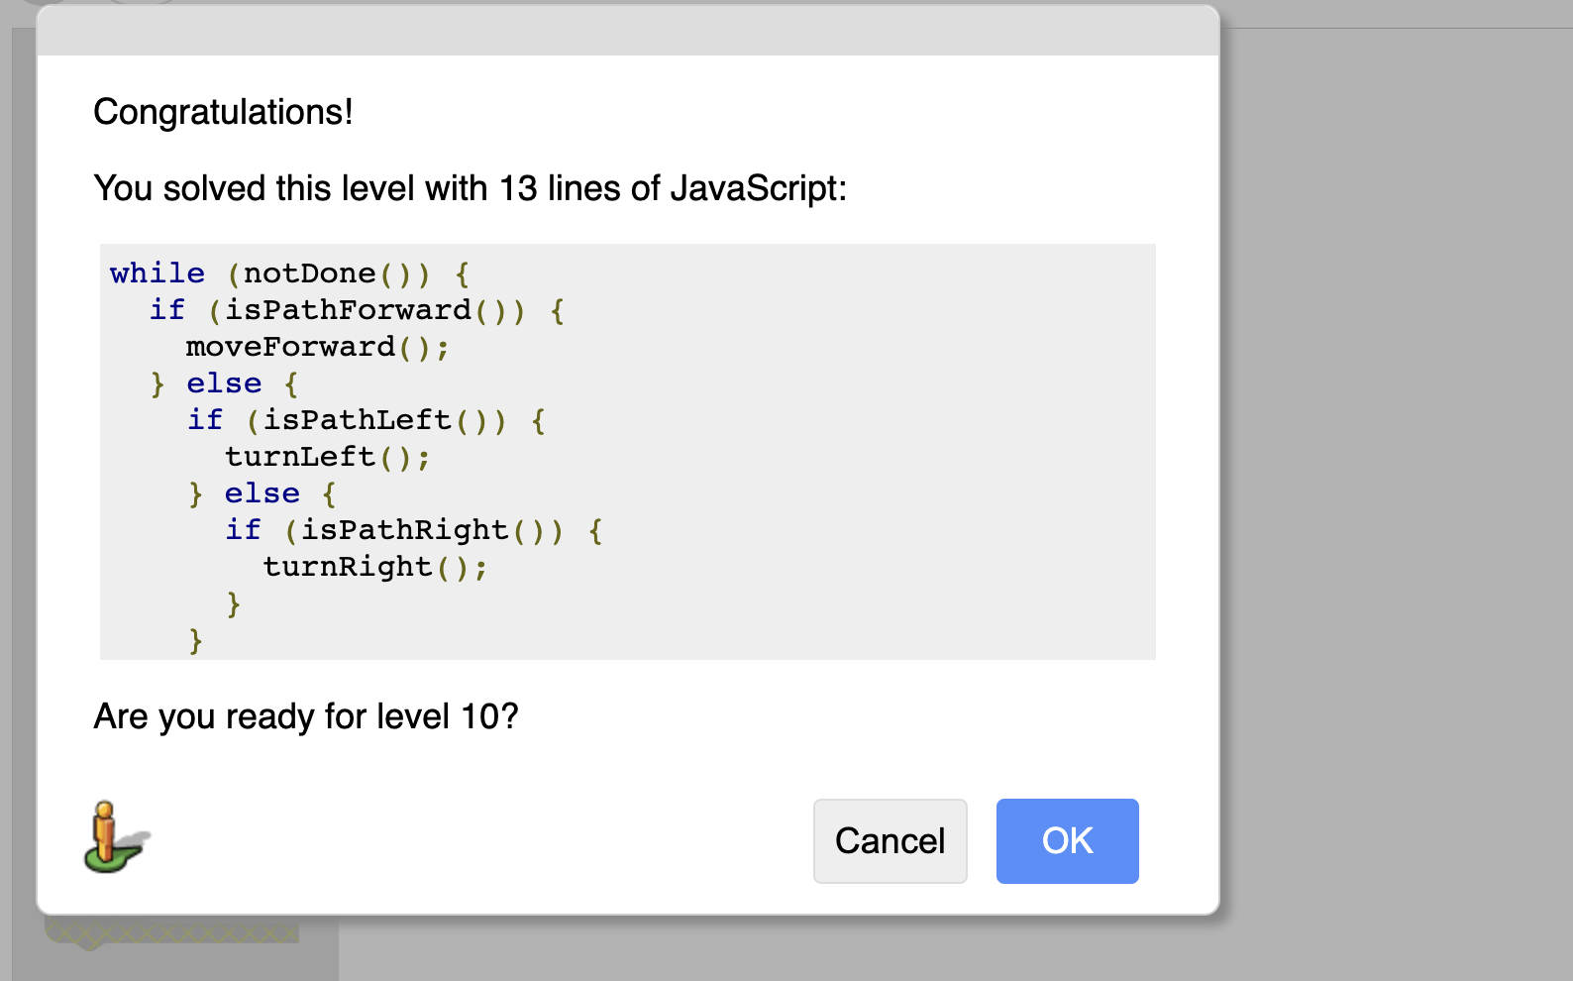

1. Use the idea above to complete level 10.